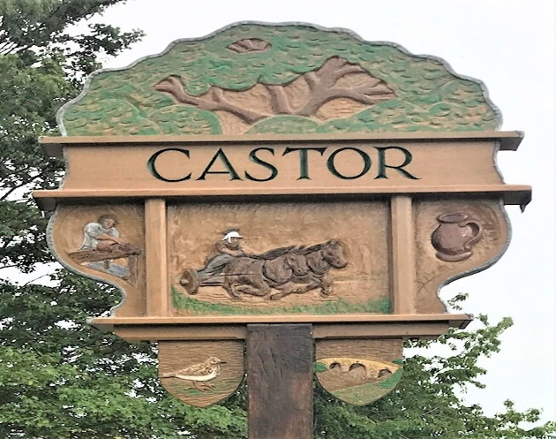

CASTOR PARISH COUNCIL

Chairman’s Report
May 2021

Through what has been a difficult year for the parish council and all residents due to the Covid 19 pandemic, I would personally like to thank the vice-chair, clerk and fellow councillors for their support over the past year.
I would also like to pass on my gratitude to the Village’s Covid Support Group, Peterborough City Councils Covid Hub, volunteers, community groups and businesses who have assisted our residents in their time of need.
I’m sure we are all looking forward to our way of life returning to as near normal as possible, but remembering the lessons of the past year where through the acts of so many our community has become so much stronger and a real sense of community cohesion has prevailed.

Throughout the past year the Parish Council has continued its work on behalf of the residents which have included the following:
The commissioning of a new Parish Council website.
Adoption of the Langdyke Trust Parish Nature Recovery Plan, with some projects having been completed, projects currently being undertaken and many more planned for the future. Funding of £6,000.00 agreed.
The implementation of the 20mph speed limit throughout the village with further work on-going including the procurement and installation of a new speed indication sign.
The formation of a Road Safety Group with our neighbouring Parish of Ailsworth.
The formation of a Task and Finish Group reviewing Assets of Community Value.
The procurement and installation of new Parish Council notice boards.
The adaptation of the redundant bus shelter into a book exchange.
Consultation on 27 planning applications.
Continued planned maintenance scheme for all Parish Land.
Continued consultation on the new Care Home on the former Woodlands site.
Continued consultation with Nene Park Trust on the Woodlands Sports Fields.
Continued support to the Good Neighbours-Rural Peterborough Trust.
Support for the village shop during its refurbishment.
Procurement of the Christmas Tree.
Funding of £1,100.00 to the Friends of Castor School for purchasing computer tablets for vulnerable children.
Funding of £200.00 to Magpas Air Ambulance.
Funding of £200.00 to Camsar (Cambridgeshire Search and Rescue) following their assistance in Castor.
The commitment of £5,000.00 to support the community in combating Climate Change.

Objectives

Further manage and enhance the Parish assets, including further projects through the Nature Recovery Plan
Preserve, support and promote local amenities and community groups.
Consult and comment on local planning applications.
Support local community based initiatives.
Provide an unbiased and balanced approach to all interests and concerns of the community.
Provide support to all age groups within the parish.
Continue to provide a voice within the City Council via the Scrutiny Committee and Parish Liaison Working Group.

